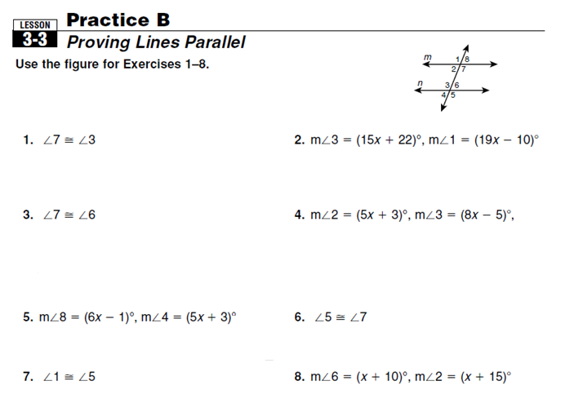

m< 6 + m< 7 = 180

ODDS: Write the postulate or theorem that proves line m is parallel to line n. EVENS: Find the value of x that makes the lines parallel.

**7. $<1 ≅ <5$ 8. $m<7=\left(2x+5\right)°, m<6=(3x+15)°$**