2017 - 2018 Algebra 1 Syllabus

What is Algebra?
Algebra is the use of numbers, symbols, and variables used to help express a difficult problem in a clear, organized, and solvable manner. Algebra gives us methods and approaches for solving problems we may encounter in our daily lives.
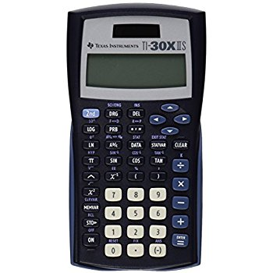

Essential Understandings
In this course you will:
- Reason with equations and inequalities.
- Reason with polynomials, exponents, and quadratics
- Interpret functions
- Analyze data

Supplies
Please bring the following materials to class each day (unless otherwise instructed):
- Chromebook
- 5 Subject Notebook
- Pencils, pens, and highlighters (used primarily as note-taking tools)
- Scientific calculator (Texas Instruments TI30XIIS model is recommended – approx. $12)
- 3-ring binder (preferable 1 ½ inch width), Notebook divider tabs

On-line Textbook Information
You may access a full version of the textbook used in this course online at www.bigideasmath.com. This site also provides video tutorials and homework help.

- Click on “Looking for Easy Access Materials?”
- Click the “Click Here” button at the bottom of the screen
- Under the drop down menu choose “Bridge to Success – HS”, then click “Go”
- Choose “Algebra 1”

Keys for Success
- Take notes over all lectures and discussions
- Turn in completed work on time
- Study for Exams
- Contribute to class discussions
- Actively engage in learning

Be POSITIVE and Give your Best EFFORT.
Practice – Assignments, Quizzes, Activities
You will be expected to complete assignments for this course daily. These assignments allow you the opportunity to practice the skills taught during class. Assignments will be checked on a regular basis. You will also be asked to complete writing assignments periodically. You will not be evaluated on grammar, but rather the content of your writing samples.

Formative Assessments – Proficiency Checks
You will be given the opportunity to demonstrate proficiency over the material in this course on a regular basis. Each proficiency check can be retaken one time and must be done within one week. Retakes will be arranged on an individual basis and may require mandatory tutoring. There will be no maximum score limitations placed on retake attempts.

Summative Assessments – Chapter Tests
Summative assessments will be given in this class. All assessments will include a multiple choice common assessment. Summative Assessments cannot be retaken.
If you miss only the review day before a scheduled test, you may choose to take the test with the rest of the class or schedule a time before or after school to make up the test.

Course Grades
Grades for this course will be divided into two general categories:

- Practice – worth 5% of the grade
- Formative Assessments – worth 20% of the total grade
- Summative Assessments – worth 75% of the total grade

Each six-week grade is cumulative. The semester grade is then calculated using 90% of the cumulative course grade and 10% of the final exam grade.

RPHS Grading Policy
A 93-100 B- 80-82 D+ 68-69
A- 90-92 C+ 78-79 D 63-67
B+ 88-89 C 73-77 D- 60-62
B 83-87 C- 70-72 F 0-59

LATE WORK POLICY (See RPHS Policy)
At Raymore-Peculiar High School, academic achievement, student responsibility, and student success are of paramount importance. Therefore, all assignment deadlines will be strictly adhered to as defined by the classroom teacher. Students who fail to submit any work at the time of a deadline can expect that a zero will be entered for their grade.

Extra Help
Students may come in for extra help whenever needed. Please try to schedule times with me in advance in order to avoid schedule conflicts.

Freshman Math Website
Information for the class can be reached by going to www.raypecmath.weebly.com . From there you can choose your teacher’s specific website for more detailed classroom information.

