1. Write a justification for each step. Given: . . Prove and are supplementary.

|  |  |
| --- | --- |
| Statements | Reasons |
| , | 1. |
|  | 2. |
|  | 3. |
|  | 4.Addition POE |
|  | 5. |
| and are supplementary | 6. |

1. 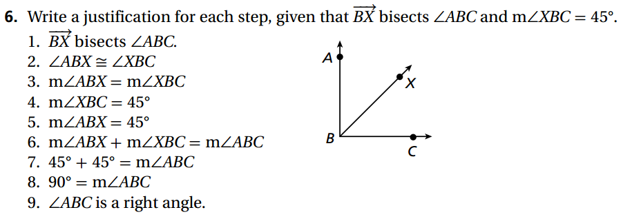Write a justification for each step. Given:  bisects . . Prove:  is a right angle.

|  |  |
| --- | --- |
| Statement | Reason |
| bisects | 1. |
|  | 2. |
|  | 3. |
|  | 4. |
|  | 5. |
|  | 6. |
|  | 7. |
|  | 8. |
| is a right angle | 9. |

1. **Given: 2x + 5 = 9 Prove: x = 2**

|  |  |
| --- | --- |
| **Statement** | **Reason** |
|  |  |
|  |  |
|  |  |
|  |  |
|  |  |

1. 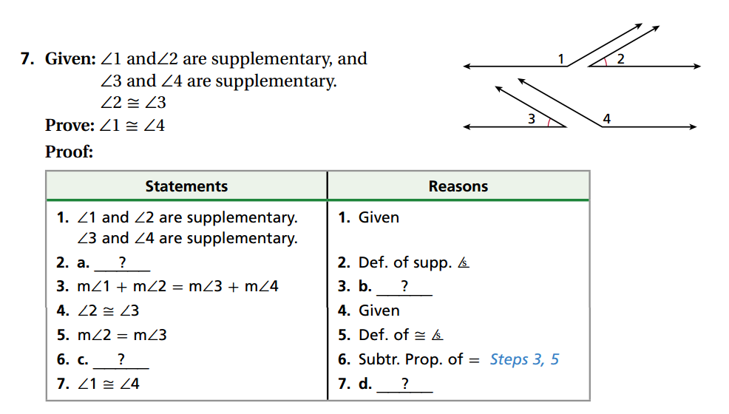

|  |  |
| --- | --- |
| Statement | Reason |
| and are supplementary  and are supplementary | Given |
| a. | Definition of Supplementary Angles |
|  | b. |
|  | Given |
|  | Definition of Congruence |
|  | c. |
|  | d. |
|  | e. |

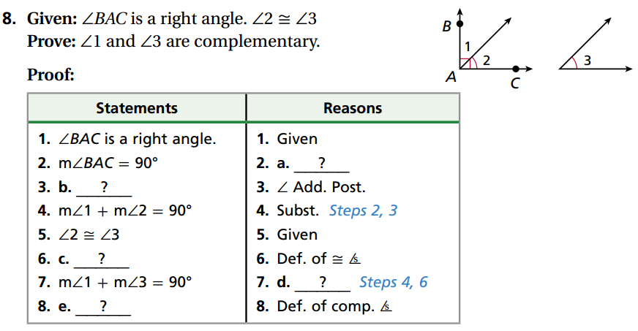

1. Given: is a right angle. 

Prove: and are complementary

|  |  |
| --- | --- |
| Statement | Reason |
| is a right angle | Given |
|  | a. |
| b. | Angle Addition Postulate (Look at the picture) |
|  | Substitution |
|  | Given |
| c. | Definition of Congruent Angles |
|  | d. |
| e. | Definition of Complementary Angles |

7. Given:  and  are complementary angles. 

Prove: 

|  |  |
| --- | --- |
| Statement | Reason |
|  |  |

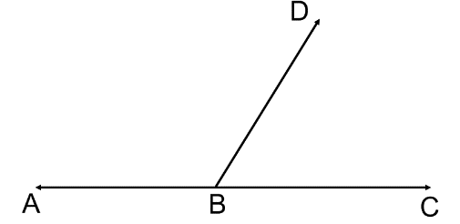

8. Given:  and  form a linear pair. 

Prove:  (This should take

|  |  |
| --- | --- |
| **Statement** | **Reason** |
|  |  |

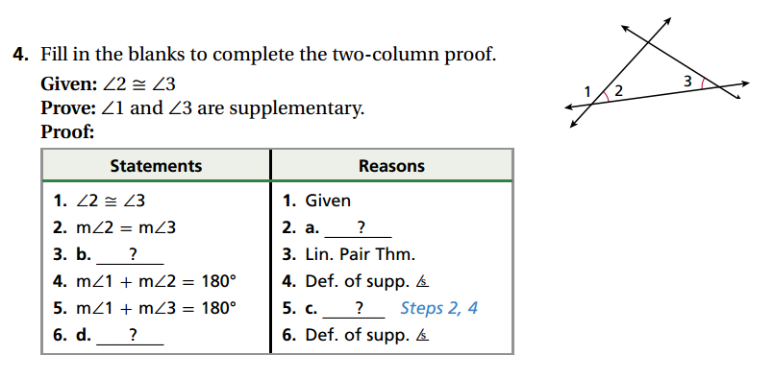**9.** Fill in the blanks to complete the proof.



|  |  |
| --- | --- |
| Statement | Reason |
|  | Given |
|  | a. |
| b. | Linear Pair Theorem |
|  | c. |
|  | d. |
| e. | Definition of Supplementary Angles |